Section 10.1. Graves’ disease

Section 10.1.1. Principal analysis Graves’ disease

Table 10.1.1.1. Attrition table for the cohort with Graves’ disease
Exclusion criteria | Datasource TEST
Total persons in the data instance | 8,861
Sex or birth year missing or absurd or no dates of entry or exit, or incomplete date of death or birth, or observation period too short | 236 (2.7%)
Exit from data source before 1 Jan 2017 | 181
No disease codes identified after study entry | 8,435 (95.2%)
Disease codes found during lookback | 0 (0%)
Other criteria suggesting the disease is present during lookback | 0 (0%)
Total cohort of Graves' disease | 9 (0.1%)
Persons dying before entrance in the follow-up | < 5
Persons leaving alive the cohort before entering the follow-up (censoring) | 0 (0%)
Persons entering follow-up | 7 (0.1%)

Table 10.1.1.2. Characteristics of the study cohort with Graves’ disease
Cohort characteristics | Datasource TEST
Total cohort population | 9
Female (n/%) | 7 (77.8%)
Male (n/%) | < 5
Other (n/%) | 0 (0%)
Age in year (IQR): PCT 25 | 32
Age in year (IQR): PCT 50 | 41
Age in year (IQR): PCT 75 | 50
Age in categories (n/%): < 18 | 0 (0%)
Age in categories (n/%): 18-59 | 8 (88.9%)
Age in categories (n/%): > 60 | < 5
Number of persons who started the follow-up | 7 (77.8%)
Total follow-up time regardless of interruptions from start of follow-up (PY) | 19
Number of vaccinations during follow-up (median, IQR) | 0 (0-2.5)
Number of people with vaccinations (n/%): 0 | < 5
Number of people with vaccinations (n/%): 1 | < 5
Number of people with vaccinations (n/%): 2 | 0 (0%)
Number of people with vaccinations (n/%): 3 or more | < 5

Table 10.1.1.3. Comorbidities in the study cohort with Graves’ disease
Covariates at baseline | Datasource TEST
Total cohort population | 9
Immunocompromise status (n/%) | < 5
Malignancy (n/%) | < 5
Infection (n/%) | < 5
Hepatitis C (n/%) | 0 (0%)
Immunostimulants (n/%) | 0 (0%)
PD-1/PD-L1 (Programmed cell death protein 1/death ligand 1) inhibitors (n/%) | 0 (0%)
Analgesics (n/%) | 0 (0%)
Systemic corticosteroids (n/%) | < 5
Antithrombotic agents (n/%) | 0 (0%)
Sex hormones (n/%) | 0 (0%)
Immunosuppressants (n/%) | < 5
Diabetes medications (n/%) | 0 (0%)
Antibiotics (n/%) | < 5
Antiviral drugs (n/%) | 0 (0%)
Antimycotics (n/%) | 0 (0%)
Non-steroidal anti-inflammatory drugs (n/%) | < 5
Drug to treat mental health diseases (n/%) | 0 (0%)
Lipid lowering drugs (n/%) | < 5
Cardiovascular medication (n/%) | < 5
Oncologic drugs (n/%) | 0 (0%)
Anti-epileptics (n/%) | 0 (0%)
Diuretics (n/%) | 0 (0%)
Tumor necrosis factor (TNF) inhibitor (n/%) | 0 (0%)

Table 10.1.1.4. Background incidence rate of first, second, and third flare in the cohort of Graves’ disease, per 1,000 person-years, with 95% confidence intervals.
Cohort characteristics | Datasource TEST
Total cohort population | NA
Number of persons who started the follow-up | 7
Number of flares before entering follow-up | 0
Number of persons who develop a first flare-up episode | < 5
IR of first flare-up episode, per 100,000 (CI 95%) | 14554.7 (1762.6-52576.6)
Number of persons still in the study 90 days after first flare | < 5
Number of persons who develop a second flare-up episode | < 5
IR of second flare-up episode, per 100,000 PY (CI 95%) | 59487 (1506.1-331440.2)
Number of persons still in the study 90 days after second flare | < 5
Number of persons who develop a third flare-up episode | < 5
IR of third flare-up episode, per 100,000 PY (CI 95%) | 195320.9 (4945.1-1088258.2)

Table 10.1.1.5. Six- and twelve-months cumulative incidence of flares of Graves’ disease, per 1,000 persons, with 95% confidence intervals.
Days | Datasource TEST
180 | 0 (0-0)
365 | 0.167 (0-0.417)

Section 10.1.2. Other analysis Graves’ disease

Table 10.1.2.1. Impact of the ablation of prompts on the attrition in the cohort with Graves’ disease
Steps in ablation analysis | Datasource TEST
Subjects with at least one disease diagnosis during study period, Main, n | 9
Subjects with at least one disease diagnosis during study period, Ablation analysis keeping PC, n (%) | 9 (100%)
Subjects with at least one disease diagnosis during study period, Ablation analysis keeping Inpatient and medicines, n (%) | 9 (100%)
Subjects with at least one disease diagnosis during study period, Ablation analysis keeping Inpatient, specialist and medicines, n (%)
At least one disease diagnosis during look-back, Main, n | 0
At least one disease diagnosis during look-back, Ablation analysis keeping PC, n | 0
At least one disease diagnosis during look-back, Ablation analysis keeping Inpatient and medicines, n | 0
At least one disease diagnosis during look-back, Ablation analysis keeping Inpatient, specialist and medicines, n
Additional exclusion criterion, Main, n | 0
Additional exclusion criterion, Ablation analysis keeping PC, n | 0
Additional exclusion criterion, Ablation analysis keeping Inpatient and medicines, n | 0
Additional exclusion criterion, Ablation analysis keeping Inpatient, specialist and medicines, n
Subjects included in the study cohort, Main, n | 9
Subjects included in the study cohort, Ablation analysis keeping PC, n | 9
Subjects included in the study cohort, only in main and not in PC, n (%) | 0 (0%)
Subjects in both main and PC, n (%) | 0 (0%)
Subjects included in the study cohort, Ablation analysis keeping Inpatient and medicines, n | 9
Subjects included in the study cohort, only in main and not in Inpatient and medicines, n (%) | 0 (0%)
Subjects in both main and Inpatient and medicines, n (%) | 0 (0%)
Subjects included in the study cohort, Ablation analysis keeping Inpatient, specialist and medicines, n
Subjects included in the study cohort, only in main and not in Inpatient, specialist and medicines, n (%)
Subjects in both main and Inpatient, specialist and medicines, n (%)
Days from start of study period (1/1/2017) and first disease diagnosis (cohort entry) in the main analysis, median (IQ range) | 827 (153-1382)
Days from start of study period (1/1/2017) and first disease diagnosis (cohort entry), in the ablation analysis keeping PC median (IQ range) | 827 (153-1382)
Days from start of study period (1/1/2017) and first disease diagnosis (cohort entry), in the ablation analysis keeping Inpatient and medicines median (IQ range) | 827 (153-1382)
Days from start of study period (1/1/2017) and first disease diagnosis (cohort entry), in the ablation analysis keeping Inpatient, specialist and medicines median (IQ range) | NA (NA-NA)
Difference between cohort entry date in the main cohort and in the ablation analysis keeping PC, median (IQ range) | 0 (0-0)
Difference between cohort entry date in the main cohort and in the ablation analysis keeping Inpatient and medicines, median (IQ range) | 0 (0-0)
Difference between cohort entry date in the main cohort and in the ablation analysis keeping Inpatient, specialist and medicines, median (IQ range) | NA (NA-NA)

Figure 10.1.2.1.
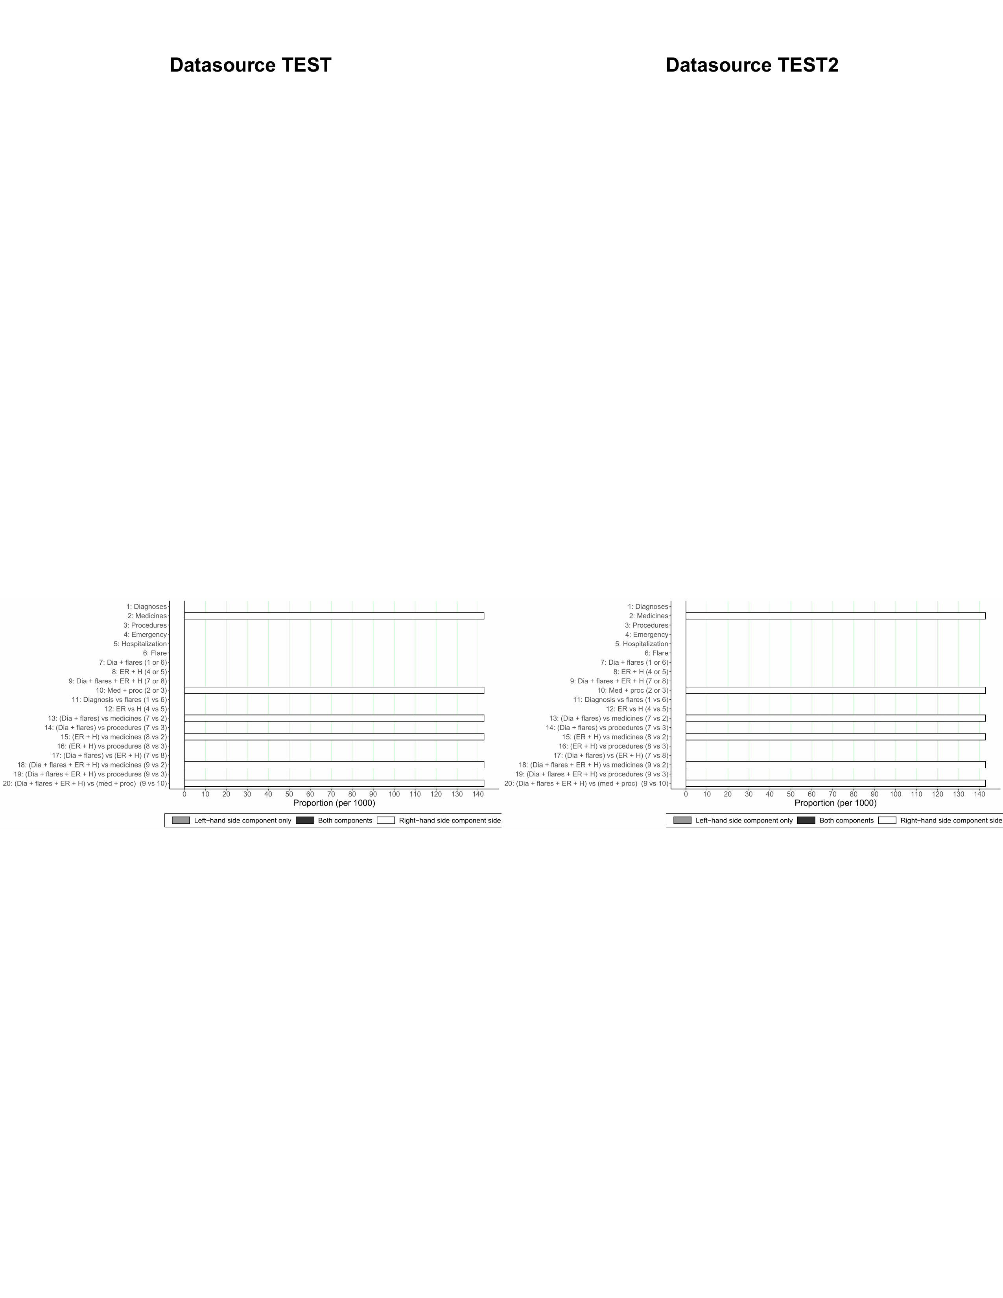

Table 10.1.2.2. Background incidence rate stratified per age categories, of first, second, and third flare in the cohort of Graves’ disease, per 1,000 person-years, with 95% confidence intervals.

Table 10.1.2.3. Background incidence rate stratified per gender, of first, second, and third flare in the cohort of Graves’ disease, per 1,000 person-years, with 95% confidence intervals.

Table 10.1.1.4. Background incidence rate in the pregnant population of first, second, and third flare in the cohort of Graves’ disease, per 1,000 person-years, with 95% confidence intervals.
Cohort characteristics | Datasource TEST
Number of persons who have at least one pregnancy after start of follow-up | NA
Number of persons who develop a first flare-up episode while they are pregnant | < 5
IR of first flare-up episode while pregnant, per 100,000 PY (CI 95%) | 14554.7 (1762.6-52576.6)
Number of persons who have at least one pregnancy after the first flare | NA
Number of persons who develop a second flare-up episode while they are pregnant | < 5
IR of first flare-up episode while pregnant, per 100,000 PY (CI 95%) | 59487 (1506.1-331440.2)
Number of persons who have at least one pregnancy 90 days after second flare | NA
Number of persons who develop a third flare-up episode while they are pregnant | < 5
IR of third flare-up episode while pregnant, per 100,000 PY (CI 95%) | 195320.9 (4945.1-1088258.2)

